Address:

B5 L4 Ipil St. Franville

Camarin Rd. Brgy.172

North Caloocan City

Zip 1400

Philippines

Date: April, 14, 2022

European Architectural Resources Ltd

Somerset House

37 Temple Street

Birmingham B2 5DP

United Kingdom

Dear Mr Fokias

You are authorised to pay money owing to my daughter, Ms Jamaica Andrea Higoy, into my personal account until further notice:

Please pay into the following Bank Account:

Beneficiary: Victor Nazal Higoy (Name of Father)

Bank: UnionBank (The Union Bank of the Philippines)

Account No: 109590905429

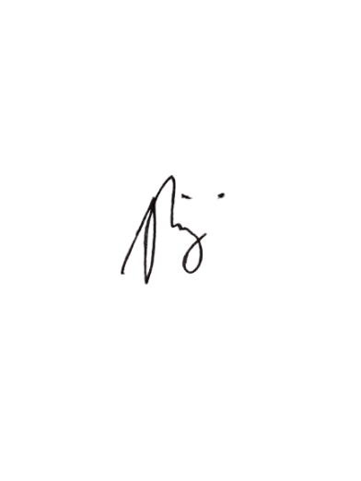

Yours sincerely

…………………………………….. Signed

Victor N. Higoy (Name)

April,14 ,2022 Date